Trevor McLaurine

6/17/2023

Assignment 4.3

Command showing all users

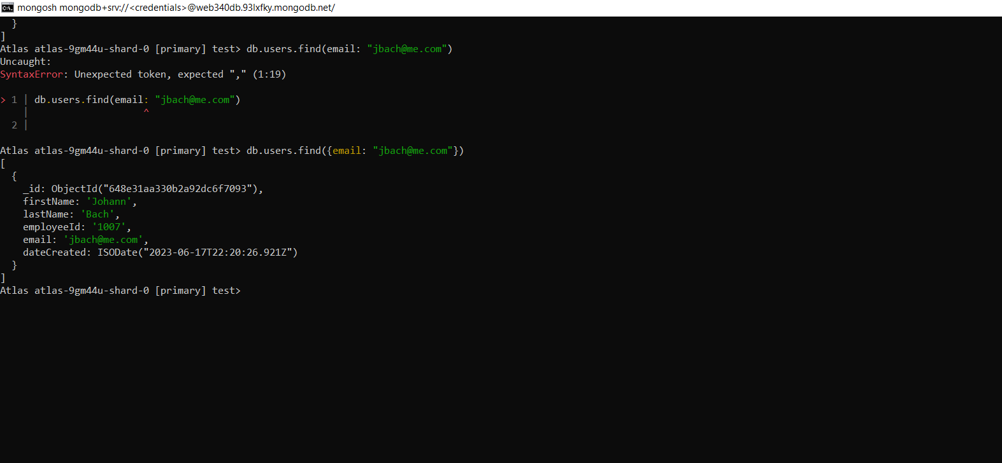

Command showing requested email:



Command showing requested last name:

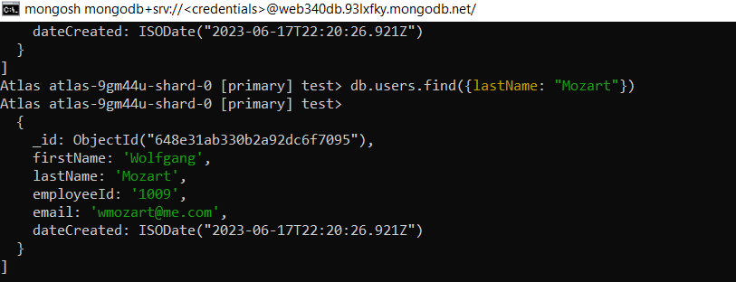

Command showing requested first name:

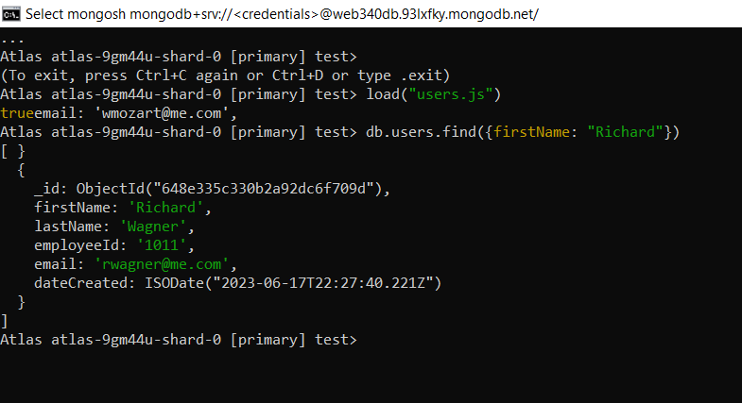

Command showing requested employee ID:

